13.1 Uses of metals
Name: ____________________ Class: ____________________ Due date: 5.15
1. Why is aluminium used to make containers for storing food? （ ）
A It conducts electricity.
B It has a high melting point.
C It is resistant to corrosion.
D It is strong.

2. Aluminium objects do not need protection from corrosion. Iron objects must be protected from corrosion.
Why does aluminium resist corrosion?（ ）
A Aluminium does not form ions easily.
B Aluminium does not react with water or air.
C Aluminium has a protective oxide layer.
D Aluminium is below iron in the reactivity series.

3. Which row shows uses of the metals listed?（ ）
 | aluminium | copper | mild steel
A | aircraft manufacture | food containers | cutlery
B | cutlery | electrical wiring | chemical plant
C | electrical wiring | aircraft manufacture | cooking utensils
D | food containers | cooking utensils | car bodies

4. Which statement about the uses of metals is not correct?（ ）
A Aluminium is used in aircraft because of its strength and good electrical conductivity.
B Copper is used in electrical wiring because of its good electrical conductivity.
C Stainless steel resists corrosion and is used to make cutlery.
D Transition elements are often used as catalysts.

5. The diagram shows a section of an overhead power cable.
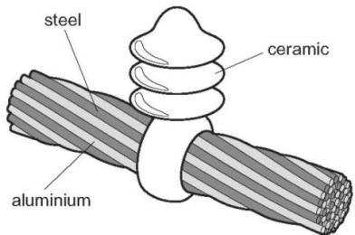
Which statement explains why a particular substance is used? （ ）
A Aluminium has a low density and is a good conductor of electricity.
B Ceramic is a good conductor of electricity.
C Steel can rust in damp air.
D Steel is more dense than aluminium.

6. Which object is least likely to contain aluminium?（ ）
A a bicycle frame B a hammer C a saucepan D an aeroplane body
7. A list of properties of aluminium is shown.
1 It conducts heat.
2 It has a low density.
3 It is resistant to corrosion.
Which properties make aluminium useful for making food storage containers?（ ）
A 1, 2 and 3 B 1 and 3 only C 1 only D 3 only

8. Electrical cables are made from either ….1. ….. because it is a very good conductor of electricity, or from….2. ….. because it has a low density. Overhead cables have a ….3. ….. core in order to give the cable strength.
Which words correctly complete gaps 1, 2 and 3? （ ）
 | 1 | 2 | 3
A | aluminium | copper | magnesium
B | copper | aluminium | magnesium
C | copper | aluminium | steel
D | magnesium | copper | steel

9. A new bicycle is being developed. Two different materials are used in its construction, both of which must be corrosion resistant.
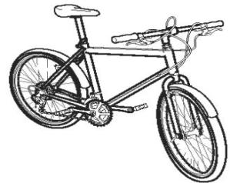
Which two metals could be used? （ ）
A aluminium and mild steel
B aluminium and stainless steel
C mild steel and pure iron
D pure iron and stainless steel

10. Which row describes the uses of aluminium, copper and mild steel? （ ）
 | aluminium | copper | mild steel
A | aircraft bodies | electrical wiring | car bodies
B | car bodies | cooking utensils | electrical wiring
C | electrical wiring | aircraft bodies | food containers
D | food containers | aircraft bodies | cooking utensils

11.Iron rusts but aluminium does not easily corrode.
Which statement explains why aluminium does not easily corrode? （ ）
A It is an alloy.
B It is below iron in the reactivity series.
C It is not a transition element.
D Its surface is protected by an oxide layer.
12. The table shows properties of four metals.
Which metal is the most suitable for aircraft construction?（ ）
 | density | strength | resistance to corrosion
A | high | high | low
B | high | low | low
C | low | high | high
D | low | low | high

13. The following are the symbols and formulae of some elements and compounds.
$$\begin{aligned}&Ar&{ Ca(OH)}_{2 }&{Cl}_{2}&{ CO}_{2} &Cu& Fe &{SO}_{2}&{ V}_{2}O_{5}\end{aligned}$$
Answer the following questions using only the elements or compounds in the list. Each element or compound may be used once, more than once or not at all.
State which element or compound is used:
to kill bacteria in drinking water............................. [1]
as a food preservative .............................[1]
as an electrical conductor in cables............................. [1]
as an inert atmosphere in lamps .............................[1]
to neutralise excess acidity in soil............................. [1]
as a catalyst in the Contact process. .............................[1]

14. Why is aluminium used extensively in the manufacture of aeroplanes?
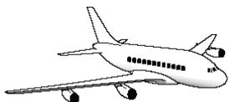

15. Aluminium is used for overhead power (electricity) cables which usually have a steel core.
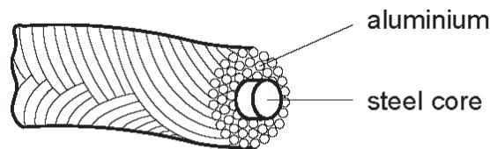
Give two properties of aluminium which make it suitable for this use.
.......................................................................................................................................
...................................................................................................................................[2]
Explain why the cables have a steel core.
......................................................................................................................................
.................................................................................................................................. [1]

